# Lab: Functions

Problems for in-class lab for the [Python Fundamentals Course @SoftUni](https://softuni.bg/trainings/3953/programming-fundamentals-with-python-january-2023).

Submit your solutions in the SoftUni judge system at <https://judge.softuni.org/Contests/1727>.

## Absolute Values

Write a program that receives a sequence of numbers, separated by a single space, and **prints** their **absolute value** as a list. Use **abs()**.

### Example

|  |  |
| --- | --- |
| **Input** | **Output** |
| 1 2.5 -3 -4.5 | [1.0, 2.5, 3.0, 4.5] |
| -0 1 10 -6.66 | [0.0, 1.0, 10.0, 6.66] |

## Grades

Write a function that **receives a grade** between **2.00** and **6.00** and **prints the corresponding grade in words**.

* 2.00 – 2.99 - "**Fail**"
* 3.00 – 3.49 - "**Poor**"
* 3.50 – 4.49 - "**Good**"
* 4.50 – 5.49 - "**Very Good**"
* 5.50 – 6.00 - "**Excellent**"

### Examples

|  |  |
| --- | --- |
| **Input** | **Output** |
| 3.33 | Poor |
| 4.50 | Very Good |
| 2.99 | Fail |

### Hints

* Read the grade from the console:



* Then, create a function and make an if statement for each case:

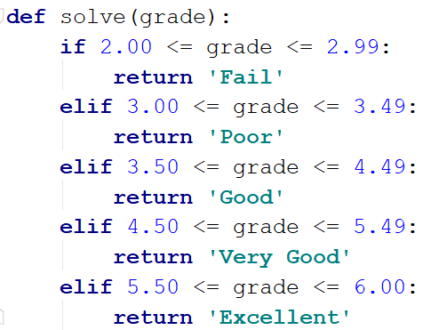

* Pass the input grade to the function:



## Calculations

Create a function that **receives** three parameters, **calculates** a result depending on the given operator, and **returns** it. Print the result of the function.

The input comes as three parameters – an **operator as a string** and **two integer numbers**. The operator can be one of the following: "**multiply**", "**divide**", "**add**", "**subtract**".

### Example

|  |  |
| --- | --- |
| **Input** | **Output** |
| subtract  5  4 | 1 |
| divide  8  4 | 2 |

### Hints

* Read the input data from the console:

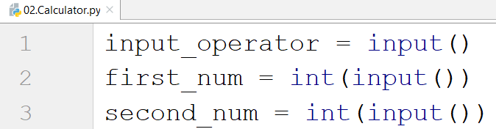

* Then, create the function and make an if statements for each case:

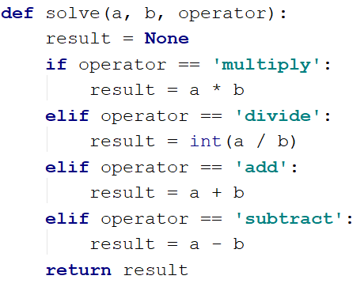

* Print the result by calling the function and passing the given parameters.

## Repeat String

Write a function that receives a **string** and a **counter** **n**. The function should **return** a new string – the result of repeating the old string **n** times. Print the result of the function. Try using **lambda**.

**Examples**

|  |  |
| --- | --- |
| **Input** | **Output** |
| abc  3 | abcabcabc |
| String  2 | StringString |

**Hints**

1. Read the input data:



1. Create the function:



1. Print the result:



## Orders

Write a function that **calculates** the **total** **price** of an order and **returns** it. The function should receive one of the following products: "**coffee"**, **"coke"**, **"water"**,or **"snacks"**, and a **quantity** of the product. The **prices** for a single piece of each product are:

* coffee - 1.50
* water - 1.00
* coke - 1.40
* snacks - 2.00

Print the result **formatted** to the **second** **decimal** **place**.

**Example**

|  |  |
| --- | --- |
| **Input** | **Output** |
| water  5 | 5.00 |
| coffee  2 | 3.00 |

## Calculate Rectangle Area

Create a function that **calculates** and **returns** the **area of a rectangle** by given **width** and **height**. **Print the result** on the console.

### Examples

|  |  |
| --- | --- |
| **Input** | **Output** |
| 3  4 | 12 |
| 6  2 | 12 |

## Rounding

Write a program that **rounds** all the given numbers, separated by a single space, and **prints the result** as a list. Use **round()**.

### Example

|  |  |
| --- | --- |
| **Input** | **Output** |
| 1.0 2.5 3.0 4.5 | [1, 2, 3, 4] |
| 2.56 1.9 -3.4 8.1 | [3, 2, -3, 8] |